A
PROJECT REPORT
ON
“CAMPUS BUDDY -
AI BASED ENQUIRY CHATBOT FOR COLLEGE”
SUBMITTED TO
DEPARTMENT OF COMPUTER APPLICATION
IN

SHRI SAIBABA SANSTHAN TRUST’S, SHIRDI
SHRI SAIBABA COLLEGE, SHIRDI
AFFILIATED TO

IN PARTIAL FULLFILLMENT OF
BACHELOR OF COMPUTER APPLICATION (BCA)
BY

- Darshan Nikam
Roll no: 18
- Tahir Khatik
Roll no: 10

BCA III SEM VI
2025 - 2026
UNDER THE GUIDANCE OF:
Prof. Deepak Bhawar
SUBMITTED TO:
Mr. Ganesh Kunjir
HOD, Computer Application Department

SHRI SAIBABA SANSTHAN TRUST'S, SHIRDI
SHRI SAIBABA COLLEGE, SHIRDI



DEPARTMENT OF COMPUTER APPLICATIONS

This is to certify that student name Tahir Khatik & Darshan Nikam of the class TYBCA(Science) has successfully completed the project titled “Campus Buddy – Ai Based Enquiry Chatbot For College” as per laid down by the S.P.P.University, pune, during the academic year 2025-26 their performance is ________________.

Project Guide Head of the department

Internal Examiner External Examiner

TABLE OF CONTENTS

1. Acknowledgement 5
2. Preliminary Investigation 6
2.1 Introduction to System (Objectives) 6
2.2 Scope of System 6
2.3 Existing System 7
2.4 Software / Hardware Requirements 8
Software Requirements 8
Hardware Requirements 8
2.5 Limitations of the System 9
2.6 Feasibility Study 9
Technical Feasibility 9
Economic Feasibility 10
Operational Feasibility 10
3. System Analysis 11
3.1 Fact Finding Techniques 11
Observation 11
Questionnaires 11
Interviews 11
Survey 12
3.2 Project Diagrams 12
ER Diagram (Entity Relationship) 12
Database Diagram 13
Class Diagram 14
Object Diagram 15
Activity Diagrams 16
Use Case Diagram 18
Sequence Diagrams 19
Collaboration Diagram 20
Component Diagram 21
Deployment Diagram 22
4. System Design 23
4.1 Data Dictionary (Tables) 23
Table 1: users 23
Table 2: departments 23
Table 3: teachers 24
Table 4: announcements 24
Table 5: faq 25
Table 6: failed_request 25
4.2 Input / Output Screens 25
Student Chatbot Interface (index.html) 26
Admin Login Screen 26
Admin Dashboard Screens 27
4.3 Reports 29
1. FAQ Report 29
2. Failed Request Report 29
3. Teacher and Department Report 29
4. Announcement Report 29
5. Feature Enhancement 30
5.1 Natural Language Processing Upgrade 30
5.2 Multi-turn Conversation Support 30
5.3 Mobile Application (Android / iOS) 30
5.4 Analytics Dashboard for Admin 30
5.5 Multi-language Support 30
5.6 Integration with University Portal 30
5.7 Voice Input and Text-to-Speech Output 31
5.8 Role-Based Admin Access 31
5.9 Email Notification System for Students 31
6. Conclusion 32
7. References / Bibliography 33
Books 33
Official Documentation 33
Online Resources 33
Academic References 33

1. Acknowledgement
We would like to express our sincere gratitude to all those who contributed to the successful completion of this project, Campus Buddy — an AI Based Enquiry for college chatbot system developed for Shri Saibaba College, Shirdi.
First and foremost, we are deeply thankful to our project guide and mentor whose continuous support, valuable guidance, and encouragement kept us motivated throughout the development process. Their technical expertise and constructive feedback played a crucial role in shaping this project into its final form.
We extend our heartfelt thanks to the Principal and the Management of Shri Saibaba College, Shirdi, for providing us with the necessary resources, infrastructure, and a supportive academic environment to carry out this project effectively.
We are also grateful to the Head of the Department of Computer Application and all the faculty members who offered their time and knowledge whenever we needed assistance. Their constant encouragement helped us overcome the technical and logical challenges we encountered during the development phase.
We sincerely thank Savitribai Phule Pune University for setting a strong academic curriculum that equipped us with the knowledge required to design and develop this system.
A special thanks goes to our classmates and friends who participated in testing the system, provided valuable feedback, and helped us identify areas of improvement. Their inputs were instrumental in refining the chatbot's responses and the overall user interface.
Finally, we are grateful to our families for their unwavering patience, understanding, and moral support throughout this journey. Without their encouragement, this work would not have been possible.
This project has been a significant learning experience for us, and we hope that Campus Buddy serves as a useful tool for students and the college administration alike.

2. Preliminary Investigation

2.1 Introduction to System (Objectives)
Campus Buddy is an AI Based Enquiry chatbot for college system specifically designed and developed for Shri Saibaba College, Shirdi. The primary goal of this project is to automate the process of answering frequently asked questions from students and providing real-time information about the college. The system is built using modern web technologies on the frontend and a Python Flask-based backend connected to a PostgreSQL database hosted on Supabase.
The chatbot uses TF-IDF (Term Frequency-Inverse Document Frequency) vectorization along with cosine similarity to intelligently match student queries to stored answers in the FAQ database. This eliminates the need for exact keyword matching and provides a more natural and accurate response mechanism.
The system is divided into two key modules: the Student Chatbot Interface and the Admin Dashboard. The student-facing chatbot allows any college student to type questions in natural language and receive instant responses. The admin panel allows authorized personnel to manage departments, teachers, announcements, FAQs, and review failed (unanswered) student requests.
The main objectives of this system are:
- To provide students with instant, accurate answers to college-related queries without human intervention.
- To maintain and manage a dynamic FAQ database that can be updated by the admin in real time.
- To record and review unanswered student queries so that the knowledge base can be expanded over time.
- To manage department and teacher information centrally within the admin panel.
- To manage announcements and important notices so students are always up to date.
- To provide a secure admin login system with password reset via OTP email verification.
- To build a scalable and maintainable system that can be extended with new features in the future.
The system is accessible from desktop as well as mobile browsers, making it highly accessible for the entire student community.

2.2 Scope of System
The scope of the Campus Buddy system covers a wide range of functionalities designed to serve both students and administrative staff of Shri Saibaba College, Shirdi. The system is focused on the following areas:
From the student's perspective, the chatbot provides a conversational interface through which students can ask questions about the college, its departments, faculty members, and general information. The chatbot processes the input question, searches the FAQ database using semantic similarity, and returns the most relevant answer. If the system fails to find a suitable answer, it records the question as a failed request for admin review.
From the admin's perspective, the system provides a secure, authenticated dashboard where administrators can add, view, and delete departments; manage teacher profiles including designation, email, and contact details; create and manage college announcements; add, manage, and delete FAQ entries; and review failed student requests to convert them into new FAQ entries.
The scope is currently limited to the college information domain. It does not cover external systems like university portals, external email notifications to students, or real-time chatting with staff. However, these can be included in future enhancements. The system is deployed using cloud-based PostgreSQL (Supabase) and a Python Flask backend, making it accessible over the internet when hosted.
The system is designed to be department-agnostic, meaning it can be adapted for any college or educational institution with minimal changes to the backend and database structure.

2.3 Existing System
Prior to the development of Campus Buddy, students seeking information about Shri Saibaba College relied entirely on manual and traditional methods of communication. These existing methods are described below:
The most common method was visiting the college office or department directly to ask questions about admissions, fees, timetables, faculty contacts, and announcements. This was time-consuming and inefficient, especially during peak periods like exam time or admission season when large numbers of students needed information simultaneously.
Another existing approach was using the college notice board, which displayed physical announcements and notices. Students had to be physically present on campus to read these notices. Important information could be missed if a student was absent or if the notice was removed.
Some colleges maintained static websites that listed basic information such as course offerings, fee structure, and contact details. However, these websites were not interactive and required manual updates. Students could not ask questions directly through the website and had to rely on phone or email communication with the administration.
Word of mouth was also a common information-sharing method among students, which led to the spread of inaccurate or outdated information. There was no centralized, reliable, always-available source of accurate answers.
The existing systems lacked interactivity, real-time updates, intelligent query handling, and 24/7 availability. There was no mechanism to track unanswered student queries or to continuously improve the information provided. Campus Buddy was developed precisely to overcome all these shortcomings and provide a modern, intelligent solution to college information management.

2.4 Software / Hardware Requirements

Software Requirements
Category | Tool / Technology | Version / Details
Frontend | HTML5, CSS3, JavaScript | Vanilla JS, No framework
Backend | Python Flask | Flask with Flask-CORS
Database | PostgreSQL | Hosted on Supabase (Cloud)
ORM | SQLAlchemy | With Pydantic for schemas
AI/ML | Scikit-learn (TF-IDF) | TfidfVectorizer + cosine_similarity
Security | Werkzeug | check_password_hash, generate_password_hash
Email | Python smtplib | SMTP Gmail for OTP sending
Scheduler | APScheduler | Database keep-alive heartbeat
Environment | python-dotenv | .env file for secrets management
Dev Tools | VS Code, Git | Version control and development

Hardware Requirements
Component | Minimum Requirement | Recommended
Processor | Intel Core i3 / AMD equivalent | Intel Core i5 or above
RAM | 4 GB | 8 GB or more
Storage | 20 GB HDD | 50 GB SSD
Internet | Broadband connection | High-speed broadband
Browser | Any modern browser | Chrome, Firefox, Edge (latest)
OS | Windows 7 / macOS / Linux | Windows 10/11 or Ubuntu 20+

2.5 Limitations of the System
While Campus Buddy provides a wide range of features and solves many problems of the existing system, it currently has the following limitations:
- The chatbot's accuracy depends entirely on the quality and quantity of FAQ entries stored in the database. If the admin has not added enough FAQs, the system may frequently fail to answer student queries.
- The system uses TF-IDF and cosine similarity for query matching. While effective, this method is not as powerful as modern deep learning-based natural language processing models such as BERT or GPT, which can understand context and nuance better.
- The current system does not support voice input or voice output. It is entirely text-based, which may be limiting for some users.
- There is no mobile application (Android/iOS) available. The system is accessed through a web browser only, though it is mobile-responsive.
- The admin panel does not support role-based access control with multiple admin levels. Currently, all admins have equal access to all features.
- The system does not send real-time push notifications or email alerts to students when new announcements are made.
- The chatbot cannot handle multi-turn conversations that maintain context across multiple messages. Each question is treated independently.
- The system does not have a built-in analytics dashboard to track chatbot performance metrics such as daily active users, most asked questions, or answer success rates.
- Currently, the backend is hosted locally and requires deployment to a public server for external access. Cloud deployment configuration is not automated.

2.6 Feasibility Study

Technical Feasibility
The project is technically feasible as it uses widely supported and well-documented technologies. Python with Flask is a lightweight, stable backend framework used extensively in web application development. PostgreSQL is a mature, reliable relational database with excellent cloud support via Supabase. The AI component uses Scikit-learn's TF-IDF, which is a proven technique for text similarity. All these technologies are open-source, well-supported, and have large developer communities, making technical implementation and future maintenance straightforward.

Economic Feasibility
The system is economically feasible as all technologies used are open-source and free of cost. The development requires only standard computing hardware and an internet connection. Supabase offers a free tier for database hosting, and Gmail's SMTP service is used for free email-based OTP. The total cost of development is minimal, limited mainly to developer time and a basic hosting infrastructure. Compared to the cost of hiring staff to answer student queries manually, the automated chatbot system provides significant long-term cost savings for the college.

Operational Feasibility
Operationally, the system is simple to use. The student chatbot interface is clean, intuitive, and does not require any training. Students can type their questions naturally and receive answers immediately. The admin panel is also designed to be user-friendly, with clear sections for each management task. The college administration staff can manage the system with minimal technical knowledge. The system operates 24/7 without human intervention, making it highly operationally viable for an educational institution.

3. System Analysis

3.1 Fact Finding Techniques

Observation
Direct observation was used as one of the primary fact-finding techniques during the initial phase of the project. The development team observed the daily activities in the college office and student interaction points to understand how students currently seek information. It was observed that during admission season, college office hours, and exam periods, large numbers of students gathered at the inquiry counter to ask similar repetitive questions. The front office staff spent most of their time answering the same questions repeatedly — such as admission deadlines, department lists, fee structures, and teacher contact details. This observation directly highlighted the need for an automated information system to reduce this burden.
Observations were also made on how the college notice board was used and how often students missed important announcements. This led to the inclusion of an Announcements Management section in the admin panel.

Questionnaires
Questionnaires were distributed among students of the college to gather structured data about their information-seeking habits and problems faced. The questions focused on how frequently students visited the college office for information, what types of questions they most commonly asked, whether they would prefer a digital chatbot assistant, and what features they would expect such a system to have. The majority of respondents indicated that they frequently needed information about departments, faculty, timetables, and announcements, and that they would strongly prefer a 24/7 available digital assistant over visiting the college office in person.
The questionnaire responses also revealed that mobile accessibility was a key requirement, which led to the development of a fully mobile-responsive chatbot interface. The data collected through questionnaires was used to build the initial FAQ database for the chatbot.

Interviews
Structured interviews were conducted with key college staff members including the administrative officer, department heads, and selected faculty members. These interviews helped the development team understand the administrative side of the system — what information needed to be managed, how frequently it changed, and who should have access to manage it. The interviews revealed the need for a secure admin login system, the ability to manage departments and teacher profiles, and the ability to post announcements.
An interview with the Head of Department of Computer Application confirmed that frequently asked questions vary across departments and that the admin should be able to add department-specific FAQs. This insight shaped the design of the FAQ management module, where intents and keywords can be customized per FAQ entry.

Survey
A broader survey was conducted across multiple classes to collect quantitative data on student awareness of college digital services, frequency of information-related problems, and expectations from a chatbot system. The survey data revealed that over 80% of students lacked awareness of any official digital source for college information, and more than 70% of students had encountered situations where they could not get the information they needed in a timely manner.
The survey also identified the most commonly asked question categories: department information, teacher contacts, admission details, exam schedules, and college events. This data directly informed the design of the chatbot's suggested questions and the initial structure of the FAQ database.

Project Diagrams

ER Diagram (Entity Relationship)
The ER Diagram shows the relationships between all database entities in the system. The users/admin entity manages departments, teachers, announcements, FAQs, and failed requests. The departments entity has a one-to-many relationship with teachers, meaning one department can have multiple teachers.

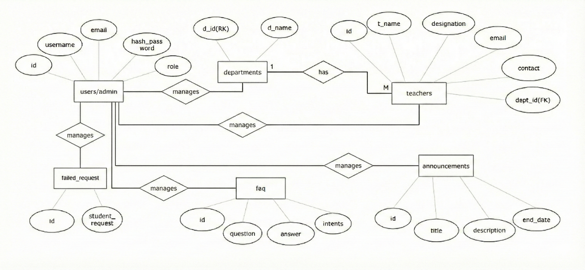

Database Diagram
The Database Diagram illustrates the physical database table structure including column names, data types, primary keys (PK), and foreign key (FK) relationships between tables.

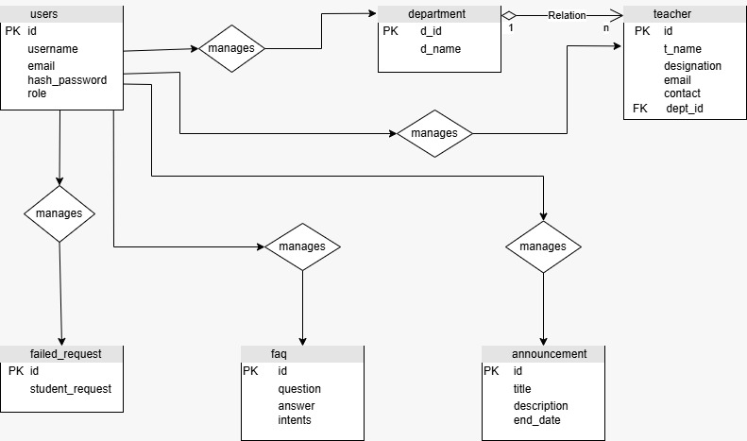

Class Diagram
The Class Diagram represents the Python SQLAlchemy model classes: users, department, teacher, announcement, faq, and failed_req. Each class maps to a database table and defines its attributes and their data types.

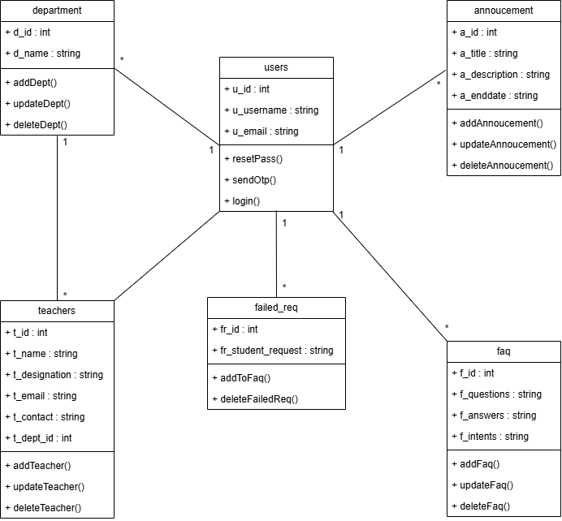

Object Diagram
The Object Diagram shows specific runtime instances of the system's classes with sample data values. For example, admin1 : User with u_id=1, u_username='Tahir', csDept : department with d_name='CS', ann1 : Announcement with a_title='Holiday', faq1 : FAQ with f_question='Fees', and fr1 : failed_req.

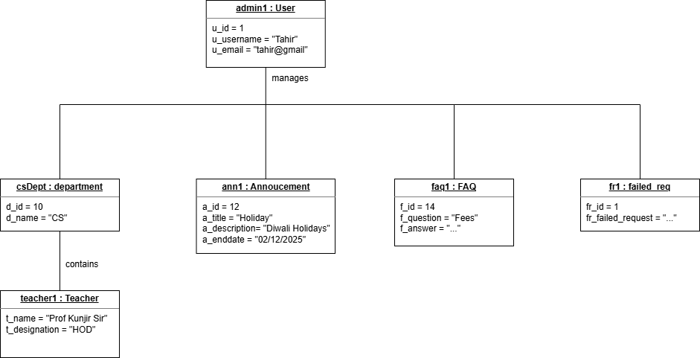

Activity Diagrams
Admin Activity Diagram: Shows the flow starting from Admin Login, through the Authentication decision, to the five management activities: Manage Department, Manage Teacher, Manage FAQ, Manage Failed Requests, and Manage Announcement.

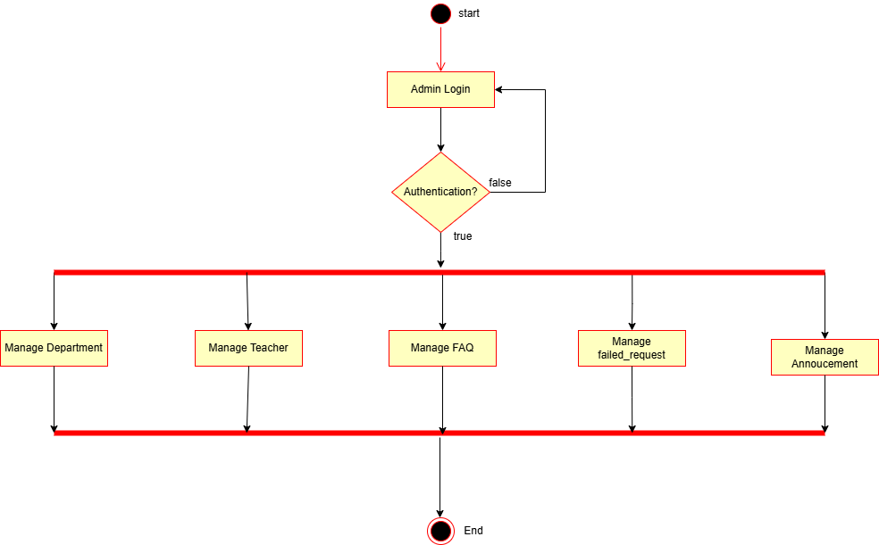

User/Student Activity Diagram: Illustrates the student's flow — Open Chatbot, Enter Question, Search in FAQ database. If an answer is found, it is displayed. If not, the question is stored in the failed_request database and the admin is notified to add it to FAQs.

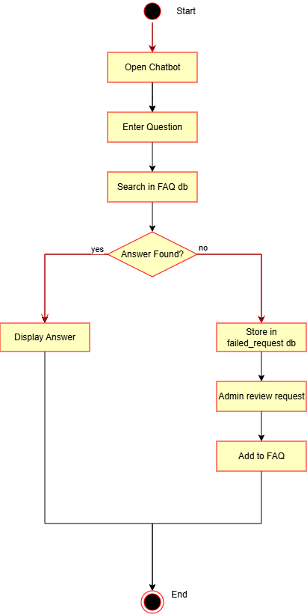

Use Case Diagram
The Use Case Diagram shows the interactions between the two main actors (Student and Admin) and the system. The Admin can Login, Manage Department, Manage Teacher, Manage FAQ, Manage Announcement, and View/Manage Failed Requests. The Student can Ask Questions, View FAQ, and View Announcements.

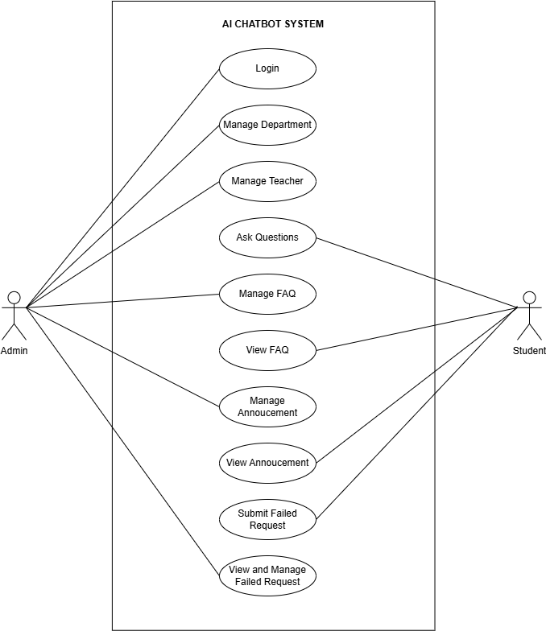

Sequence Diagrams
Student Sequence Diagram: Shows the message sequence between Student, ChatbotUI, Backend, FAQ_DB, FailedReq_DB, and Admin. When a student asks a question, it flows through the UI to the backend, which queries the FAQ database. Based on whether an answer is found, the system either returns the answer or logs the failed request.

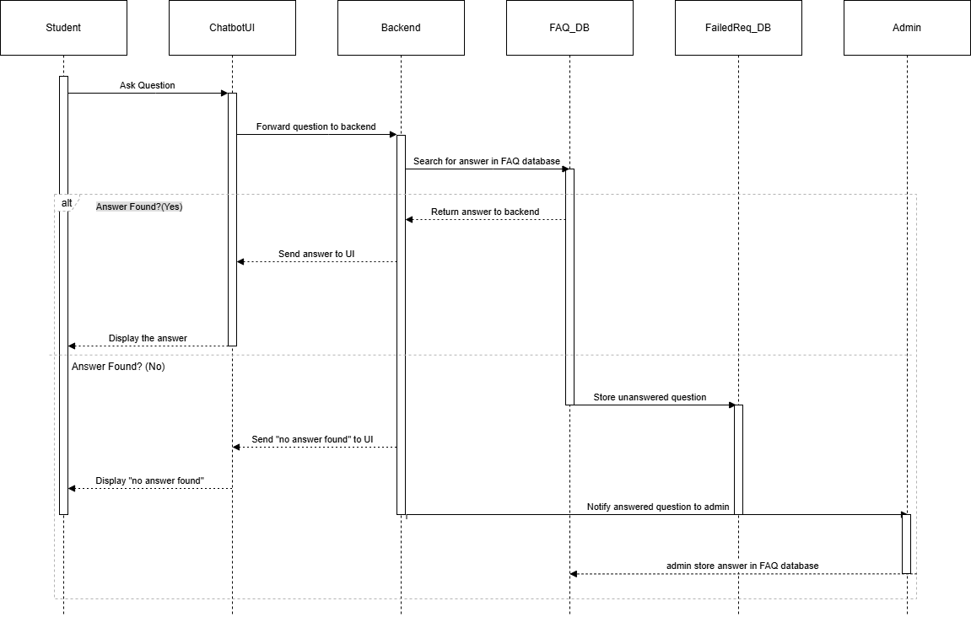

Collaboration Diagram
The Collaboration Diagram depicts the structural relationships and communication links between the major runtime objects: ChatbotUI (Interface), Backend (ChatbotSystem), FAQ (Database), admin1 (Admin), and failedReq (failed_request). It emphasizes how these objects collaborate to fulfill system functionality.

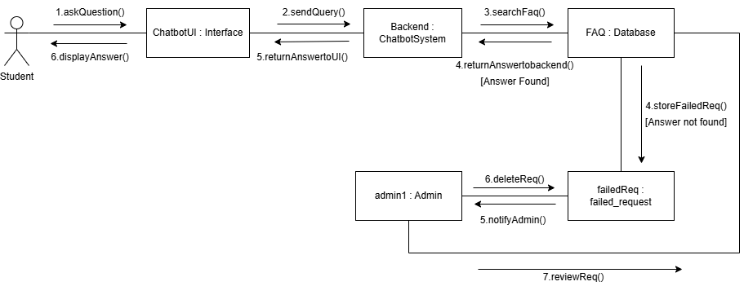

Component Diagram
The Component Diagram illustrates the high-level architecture of the system, showing how the Student Interface (Chatbot UI) and Admin Panel connect through the API Controller (Flask), which routes requests to the Auth Module, Chatbot Engine, FAQ Module, Teacher Module, Department Module, and Failed Request Handler — all backed by the PostgreSQL Database.

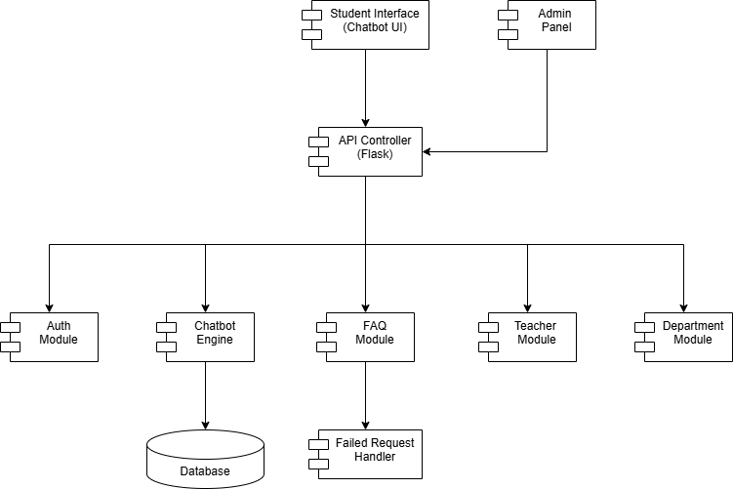

Deployment Diagram
The Deployment Diagram shows the physical deployment architecture: client devices (mobile, desktop, laptop) connect to the AI Chatbot System running on the System's Server, which contains the database. The Admin's Device also connects to the same server for management operations.

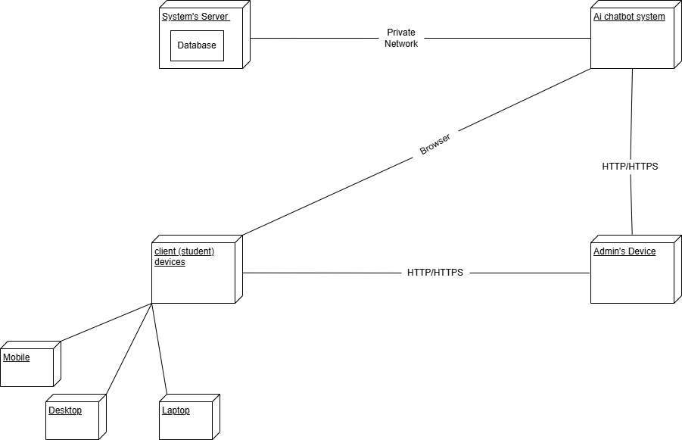

4. System Design

4.1 Data Dictionary (Tables)

Table 1: users
This table stores admin user credentials and role information for authentication.
Column Name | Data Type | Constraints | Description
id | INTEGER | PRIMARY KEY, IDENTITY, UNIQUE, NOT NULL | Unique identifier for each user
username | TEXT | UNIQUE, NOT NULL | Admin username for display
email | TEXT | UNIQUE, NOT NULL | Admin email used for login
hash_password | TEXT | UNIQUE, NOT NULL | Encrypt hashed password
role | TEXT | NOT NULL | Role of the user (e.g., admin)

Table 2: departments
This table stores the list of academic departments available in the college.
Column Name | Data Type | Constraints | Description
id | INTEGER | PRIMARY KEY, UNIQUE, IDENTITY, NOT NULL | Unique department identifier
name | TEXT | UNIQUE, NOT NULL | Name of the department (e.g., Computer Application)

Table 3: teachers
This table stores information about teachers/faculty members belonging to various departments.
Column Name | Data Type | Constraints | Description
id | INTEGER | PRIMARY KEY, UNIQUE, IDENTITY, NOT NULL | Unique teacher identifier
name | TEXT | UNIQUE, NOT NULL | Full name of the teacher
designation | TEXT | NULLABLE | Teacher's designation (e.g., HOD, Lecturer)
email | TEXT | UNIQUE, NULLABLE | Teacher's official email address
contact | TEXT | UNIQUE, NULLABLE | Teacher's contact number
department_id | INTEGER | FOREIGN KEY (departments.id) | Linked department identifier

Table 4: announcements
This table stores college announcements managed by the admin and displayed to students.
Column Name | Data Type | Constraints | Description
id | INTEGER | PRIMARY KEY, UNIQUE, IDENTITY, NOT NULL | Unique announcement identifier
title | TEXT | NOT NULL | Short title of the announcement
description | TEXT | NOT NULL | Detailed description of the announcement
end_date | DATE | NOT NULL | Expiry date of the announcement (YYYY-MM-DD)

Table 5: faq
This table stores frequently asked questions, their answers, and associated keywords/intents used by the AI matching engine.
Column Name | Data Type | Constraints | Description
id | INTEGER | PRIMARY KEY, UNIQUE, IDENTITY, NOT NULL | Unique FAQ identifier
question | TEXT | UNIQUE, NOT NULL | The FAQ question text
answer | TEXT | NOT NULL | The answer to the FAQ question
intents | TEXT | NOT NULL | Comma-separated keywords for TF-IDF matching

Table 6: failed_request
This table stores student questions that the chatbot could not answer (similarity score below threshold), allowing the admin to review and add them as new FAQs.
Column Name | Data Type | Constraints | Description
id | INTEGER | PRIMARY KEY, UNIQUE, IDENTITY, NOT NULL | Unique failed request identifier
student_request | TEXT | UNIQUE, NOT NULL | The student's unmatched question text

4.2 Input / Output Screens
The system consists of two main interface modules: the Student Chatbot Interface and the Admin Dashboard. Below are descriptions of all key screens along with the project diagrams illustrating the system flow and design.

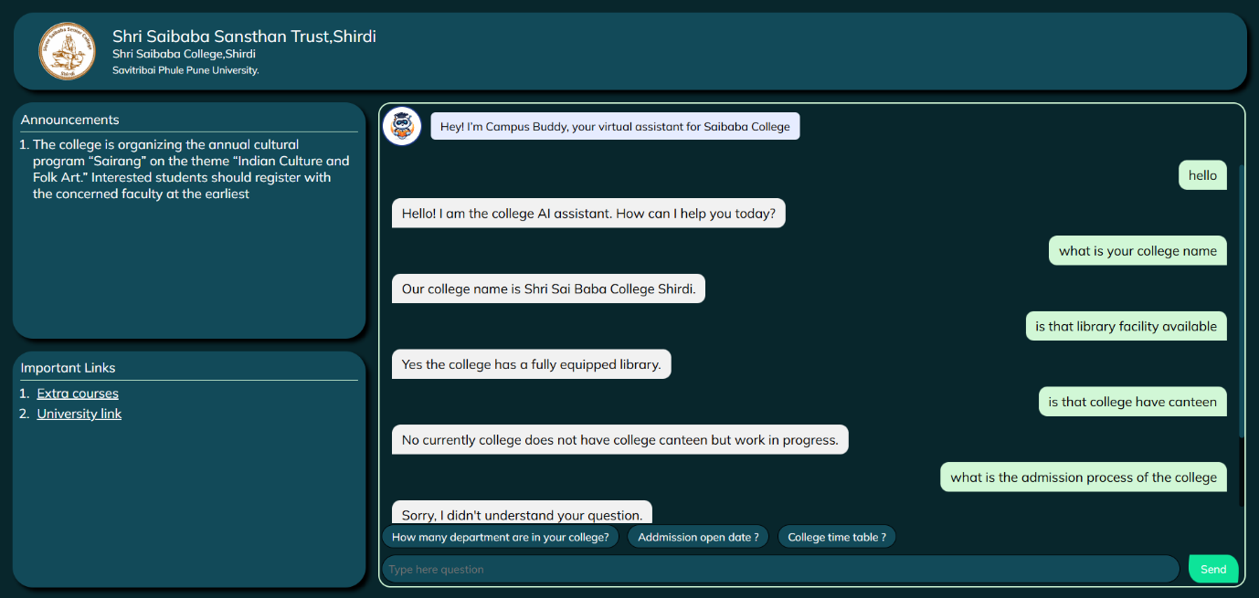

Student Chatbot Interface (index.html)
Input: The student types a question in the text input box at the bottom of the chat panel or clicks one of the predefined suggestion buttons. The question is sent as a POST request to the /chat API endpoint.
Output: The chatbot displays the answer received from the backend inside the chat body area. If no answer is found, the system responds with 'Sorry, I did not understand your question.' The chat also shows a left panel with announcements and important links accessible from the sidebar.

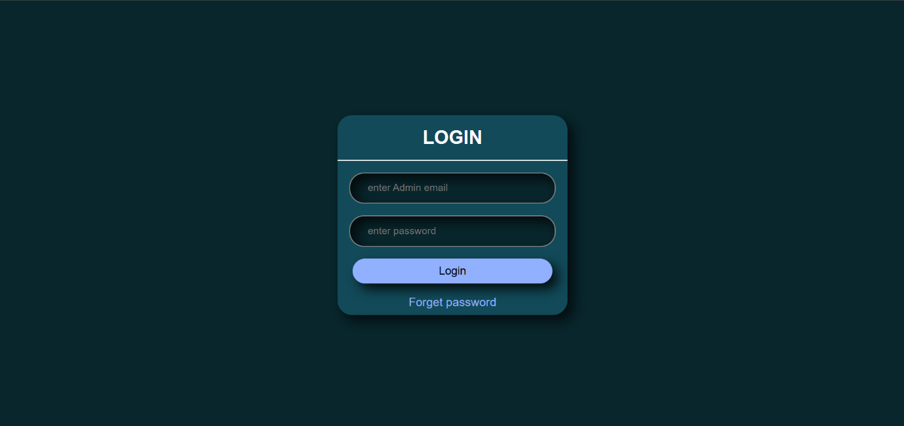

Admin Login Screen
Input: The admin enters their registered email address and password. On clicking Login, a POST request is sent to /admin/login. If credentials are incorrect, an error alert is shown.
Output: On successful authentication, the login form is hidden and the full admin dashboard becomes visible. The admin's username is displayed in a welcome alert.
Forget Password Flow: Admin clicks 'Forget Password', enters email, requests an OTP. The OTP is sent to the registered email via Gmail SMTP. The admin then enters the OTP and new password to complete the reset.

Admin Dashboard Screens
The admin dashboard contains five management sections, each with an input form and a data table:

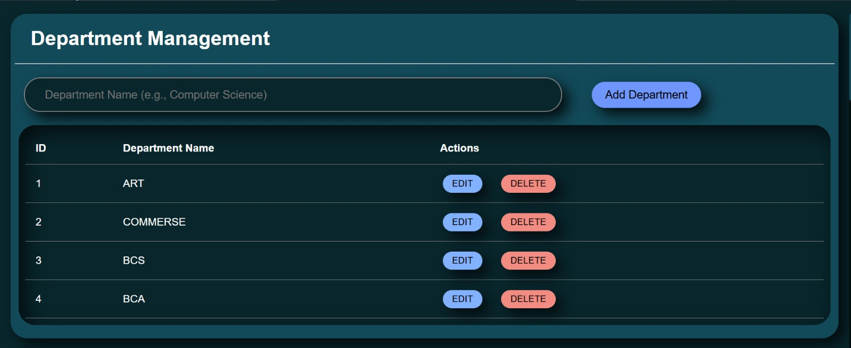
.Department Management: Admin inputs department name and clicks 'ADD DEPARTMENT'. The table displays all departments with a delete option.

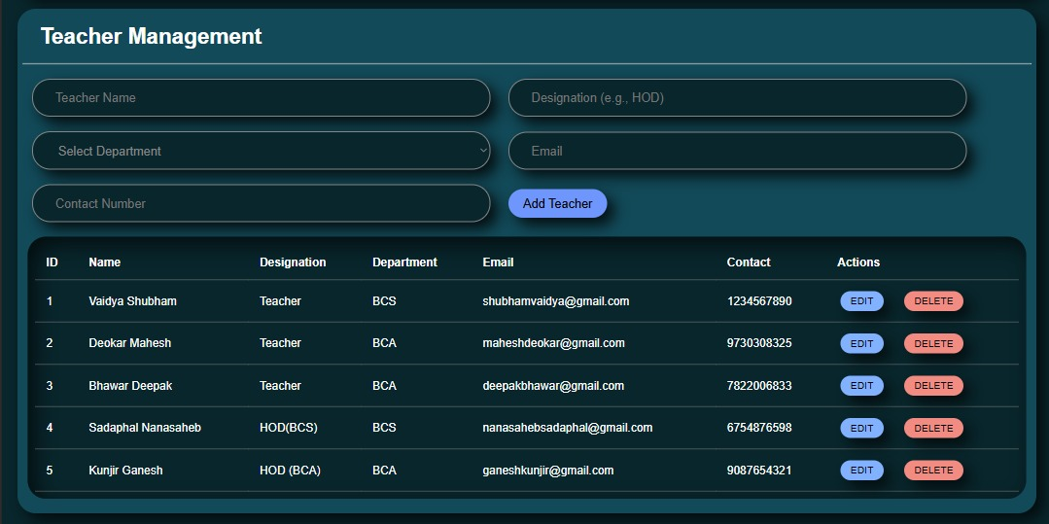
- Teacher Management: Admin fills in teacher name, designation, department (from a dropdown), email, and contact number. The teacher table lists all faculty.

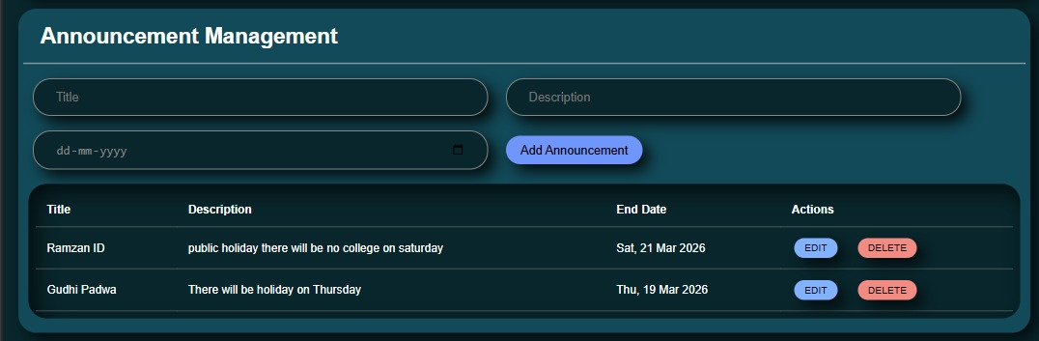
- Announcement Management: Admin enters title, description, and end date for announcements. Existing announcements are listed with edit/delete options.

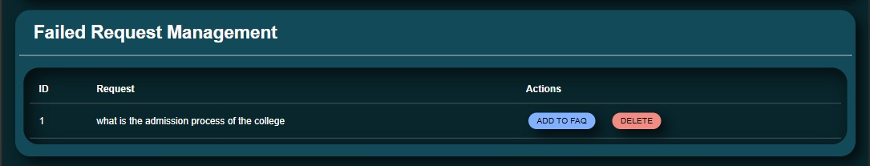
- Failed Request Management: Displays all unanswered student queries. Admin can review them and add relevant answers to the FAQ database.

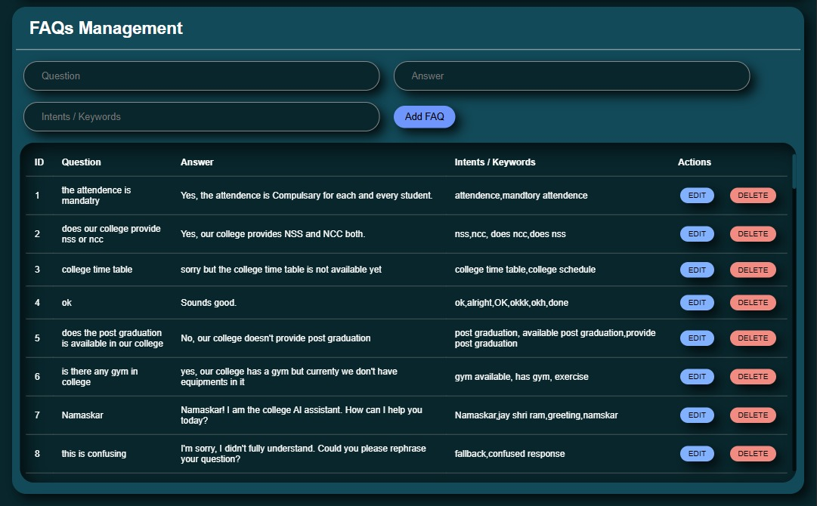
- FAQ Management: Admin adds a question, answer, and intent keywords. All FAQs are listed with delete functionality.

4.3 Reports
The system generates and maintains the following logical reports and outputs as part of its operational functionality:

1. FAQ Report
The FAQ table in the admin dashboard serves as a live report of all knowledge base entries. Each entry includes the question, answer, and associated intent keywords. The admin can view all FAQs at any time, which helps in auditing the chatbot's knowledge base and identifying gaps in information coverage.

2. Failed Request Report
The Failed Request Management section displays all questions that the chatbot was unable to answer (i.e., questions with cosine similarity below 0.4). This report helps the admin identify new topics that students are asking about and expand the FAQ database accordingly. Each failed request shows the student's original question text, allowing the admin to craft an appropriate answer and add it to the FAQ system.

3. Teacher and Department Report
The Teacher Management table provides a complete report of all faculty members, their designations, departments, emails, and contact numbers. This is useful for administrative record-keeping and can serve as a directory report. The Department Management table provides a list of all registered departments, supporting administrative oversight.

4. Announcement Report
The Announcement Management table acts as a report of all active and past announcements made by the admin. Each announcement includes its title, description, and end date, providing a historical record of college communications and notices.

5. Feature Enhancement
Campus Buddy has been designed with future scalability in mind. The following feature enhancements are planned or proposed for future versions of the system:

5.1 Natural Language Processing Upgrade
The current TF-IDF with cosine similarity approach is effective but limited in understanding complex sentence structures and context. A future enhancement would involve integrating a pre-trained transformer-based model such as BERT (Bidirectional Encoder Representations from Transformers) or a fine-tuned version of a lightweight language model. This would significantly improve the chatbot's ability to understand natural language variations and synonyms, leading to more accurate and context-aware answers.

5.2 Multi-turn Conversation Support
Currently, each student message is treated as an independent query. A future enhancement would implement conversation history management, allowing the chatbot to understand follow-up questions in the context of the previous exchange. For example, if a student asks 'Who is the HOD?' followed by 'What is his email?', the system should understand that 'his' refers to the HOD mentioned in the previous turn.

5.3 Mobile Application (Android / iOS)
A dedicated mobile application for Campus Buddy would greatly improve accessibility and user experience. Push notifications through the mobile app would allow students to receive real-time alerts about new announcements, exam schedules, and important college news without needing to open a browser.

5.4 Analytics Dashboard for Admin
An analytics dashboard would provide the admin with insights into chatbot usage patterns, including total queries per day, most frequently asked questions, percentage of successfully answered queries versus failed requests, and peak usage times. This data would help in continuously improving the knowledge base and understanding student needs better.

5.5 Multi-language Support
Adding support for regional languages such as Marathi and Hindi would make the chatbot more accessible to students who are not comfortable communicating in English. This could be implemented using translation APIs or multilingual NLP models.

5.6 Integration with University Portal
Future versions could integrate with Savitribai Phule Pune University's online portal to pull real-time data on examination schedules, results, and hall tickets. This would make Campus Buddy a comprehensive information hub for students.

5.7 Voice Input and Text-to-Speech Output
Adding voice-based interaction would make the chatbot more accessible, particularly for students with accessibility needs. Students could speak their questions aloud and receive spoken responses, improving usability on mobile devices.

5.8 Role-Based Admin Access
Implementing multiple admin roles such as Super Admin, Department Admin, and Content Manager would allow different levels of access. For example, a Department Admin could only manage teachers and FAQs within their own department, while the Super Admin would have full access to all features.

5.9 Email Notification System for Students
Students could optionally register their email addresses to receive notifications about new announcements and important updates directly in their inbox. This would ensure no student misses critical college news.

6. Conclusion
Campus Buddy is a complete, functional AI-powered chatbot system successfully developed for Shri Saibaba College, Shirdi, as a final year project. The system effectively addresses the real-world problem of students not having a quick and reliable source of college information by providing an intelligent, always-available digital assistant.
The project demonstrates the practical application of several modern technologies including Python Flask for backend development, PostgreSQL for persistent data storage, TF-IDF vectorization with cosine similarity for AI-based query matching, and HTML/CSS/JavaScript for a clean, responsive user interface. The integration of email-based OTP authentication for admin password reset adds a real-world security dimension to the project.
Throughout the development process, the team followed a structured software development lifecycle — starting from preliminary investigation and fact-finding through observation, questionnaires, interviews, and surveys — moving through system analysis, design, and implementation. The inclusion of comprehensive UML diagrams including ER, Use Case, Activity, Sequence, Class, Component, Deployment, Object, and Collaboration diagrams demonstrates a strong understanding of software engineering principles.
The admin dashboard provides a powerful yet simple interface for college staff to manage all dynamic content — departments, teachers, announcements, FAQs, and failed student requests — without requiring any technical knowledge. The automated recording of failed requests ensures that the chatbot's knowledge base can continuously grow and improve over time.
The system has been designed to be scalable and extensible. The proposed future enhancements, including NLP upgrades, mobile application development, multi-language support, and integration with the university portal, lay a clear roadmap for this project to evolve into an even more powerful and comprehensive information system.
In conclusion, Campus Buddy successfully achieves all its defined objectives and demonstrates that with thoughtful planning, modern tools, and a student-centric design philosophy, a college can significantly improve its information delivery to students while reducing the administrative burden on its staff. This project stands as a solid foundation that can be built upon to create a truly comprehensive smart college assistant in the future.

7. References / Bibliography
The following books, online resources, official documentation, and academic references were used during the research, design, and development of this project:

Books
- Pressman, R. S. (2014). Software Engineering: A Practitioner's Approach (8th ed.). McGraw-Hill Education.
- Silberschatz, A., Korth, H. F., & Sudarshan, S. (2019). Database System Concepts (7th ed.). McGraw-Hill Education.
- Grinberg, M. (2018). Flask Web Development: Developing Web Applications with Python (2nd ed.). O'Reilly Media.
- Lutz, M. (2013). Learning Python (5th ed.). O'Reilly Media.

Official Documentation
- Flask Official Documentation — https://flask.palletsprojects.com/
- SQLAlchemy Documentation — https://docs.sqlalchemy.org/
- Pydantic Documentation — https://docs.pydantic.dev/
- Scikit-learn Documentation (TF-IDF, Cosine Similarity) — https://scikit-learn.org/
- Supabase Documentation — https://supabase.com/docs
- PostgreSQL Documentation — https://www.postgresql.org/docs/
- Werkzeug Security Documentation — https://werkzeug.palletsprojects.com/
- APScheduler Documentation — https://apscheduler.readthedocs.io/

Online Resources
- W3Schools — HTML, CSS, JavaScript Reference — https://www.w3schools.com/
- MDN Web Docs — JavaScript and Web API Reference — https://developer.mozilla.org/
- GeeksforGeeks — TF-IDF and Cosine Similarity Explanation — https://www.geeksforgeeks.org/
- Stack Overflow — Technical problem-solving community — https://stackoverflow.com/
- Towards Data Science — NLP and Machine Learning Articles — https://towardsdatascience.com/

Academic References
- Manning, C. D., Raghavan, P., & Schutze, H. (2008). Introduction to Information Retrieval. Cambridge University Press.
- Jurafsky, D., & Martin, J. H. (2020). Speech and Language Processing (3rd ed. draft). — https://web.stanford.edu/~jurafsky/slp3/

